Chorzeit – Das Vokalmagazin
01 / 2020
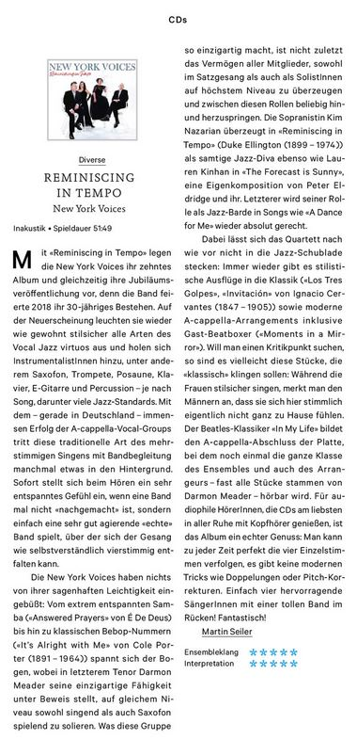

REMINISCING IN TEMPO
New York Voices
Inakustik • Spieldauer 51:49
[Translation: Google Translate]
With “Reminiscing in Tempo”, the New York Voices are presenting their tenth album and their anniversary release at the same time, because the band celebrated its 30th anniversary in 2018. On the new release, they illuminate all types of vocal jazz virtuoso as usual and bring in instrumentalists, including saxophone, trumpet, trombone, piano, electric guitar and percussion - depending on the song, including many jazz standards. With the immense success of the a cappella vocal groups, especially in Germany, this traditional type of polyphonic singing with band accompaniment sometimes takes a back seat. When listening to a band, there is a very relaxed feeling immediately when a band is not “imitated”, but simply plays a very well-acting “real” band, over which the vocals can unfold as a matter of course in four parts.
The New York Voices have lost none of their fabulous lightness: from extremely relaxed samba (“Answered Prayers” by É De Deus) to classic bebop numbers (“It's Alright with Me” by Cole Porter (1891 - 1964)) the bow, with the latter tenor Darmon Meader demonstrating his unique ability to solo both singing and playing the saxophone at the same level. Last but not least, what makes this group so unique is the ability of all members to convince at the highest level, both in vocals and as soloists, and to jump back and forth between these roles. The soprano Kim Nazarian convinced in “Reminiscing in Tempo” (Duke Ellington (1899 - 1974)) as a velvety jazz diva, as did Lauren Kinhan in “The Forecast is Sunny”, an original composition by Peter Eldridge and her. The latter lives up to his role as jazz bard in songs like "A Dance for Me".
The quartet still cannot be put in the jazz drawer: there are always stylistic excursions into the classical ("Los Tres Golpes", "Invitación" by Ignacio Cervantes (1847 - 1905)) and modern a-cappella Arrangements including guest beatboxer ("Moments in a Mirror"). If you want to look for a point of criticism, it is perhaps these pieces that are supposed to sound "classic": While the women sing stylishly, you notice that the men do not really feel at home here. The Beatles classic "In My Life" forms the a cappella ending of the record, in which the whole class of the ensemble and the arranger - almost all of the pieces are from Darmon Meader - can be heard again. The album is a real treat for audiophile listeners who prefer to enjoy CDs in peace and quiet with headphones: You can perfectly follow the four individual parts at any time, there are no modern tricks such as duplications or pitch corrections. Simply four excellent singers with a great band in the back! Fantastic!
Martin Seiler

